**Problem statement**

**Create a file max-temp.txt in local FS.**

**Put some 10-15 records of date and temperature example:**

**dd-mm-yyyy,temperature**

**Example:**

**10-01-1990,10**

**10-02-1991,20**

**Move this file to HDFS at /user/acadgild/hadoop.**

**Output**

1. **Open vi editor on local FS with file name max-temp.txt**

Command : vi **max-temp.txt**

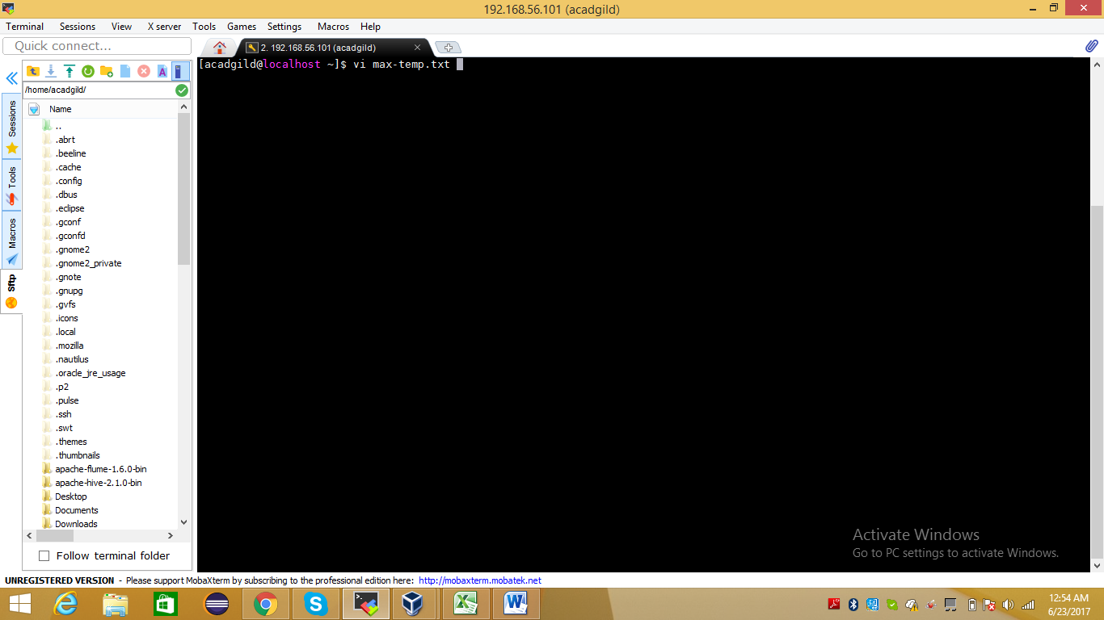

1. **Inserted records into max-temp.txt and saving file on FS**

Command : :wq for saving content of file Local FS

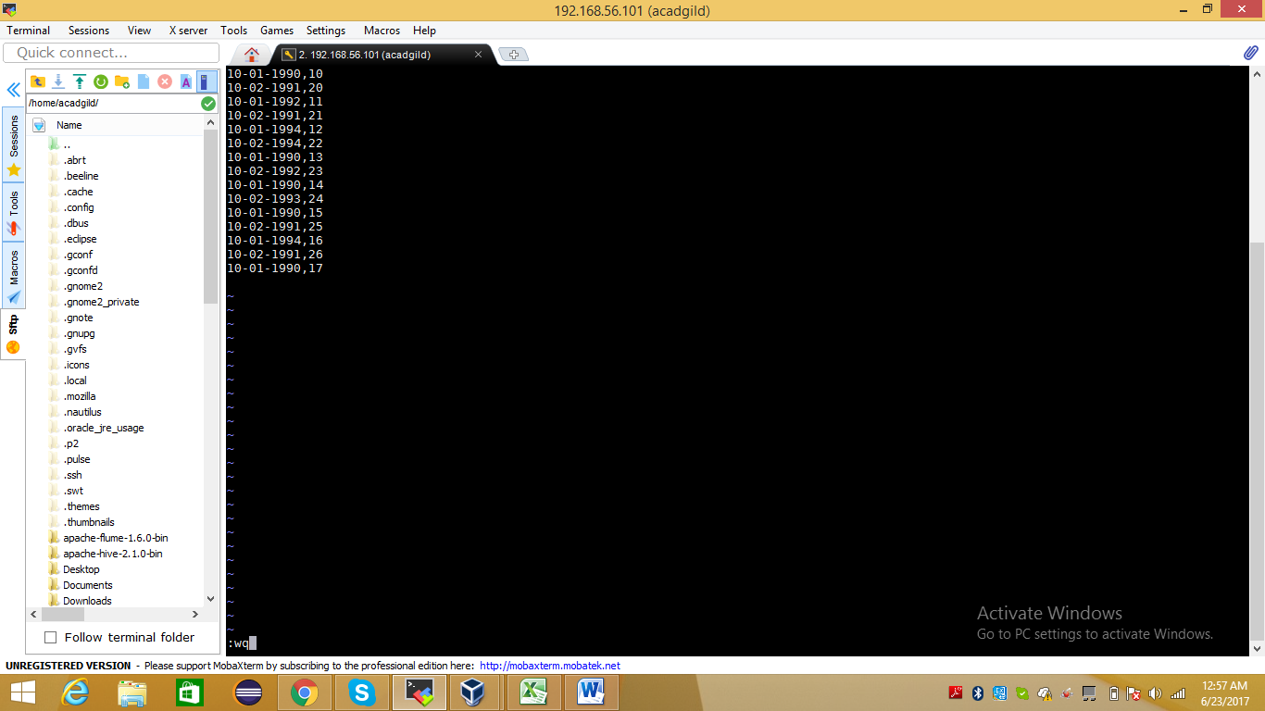

1. **File max-temp.txt has created on local FS.**

**Command : ls used to verified file creted on local FS**

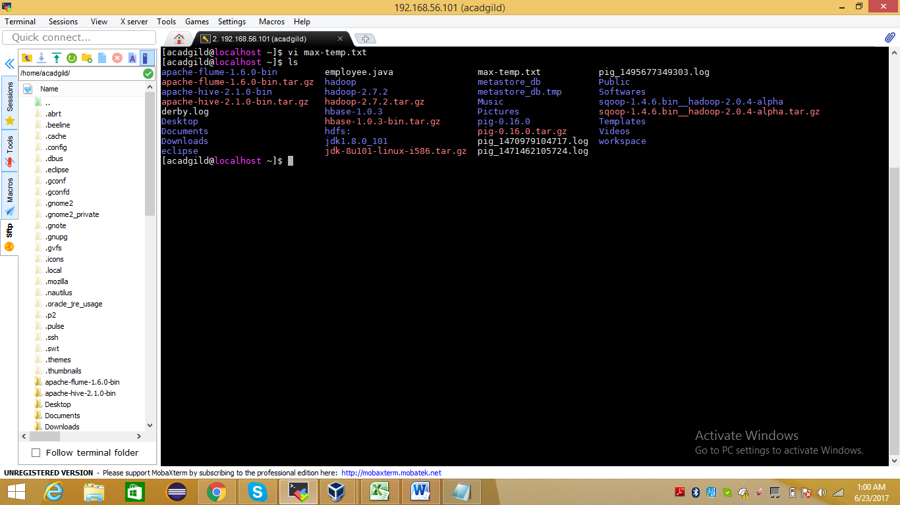

1. **Transferred file max-temp.txt from local FS to hadoop FS at /user/acadgild/hadoop, we ran below command.**

**Command : hadoop fs -moveFromLocal max-temp.txt /user/acadgild/hadoop/**

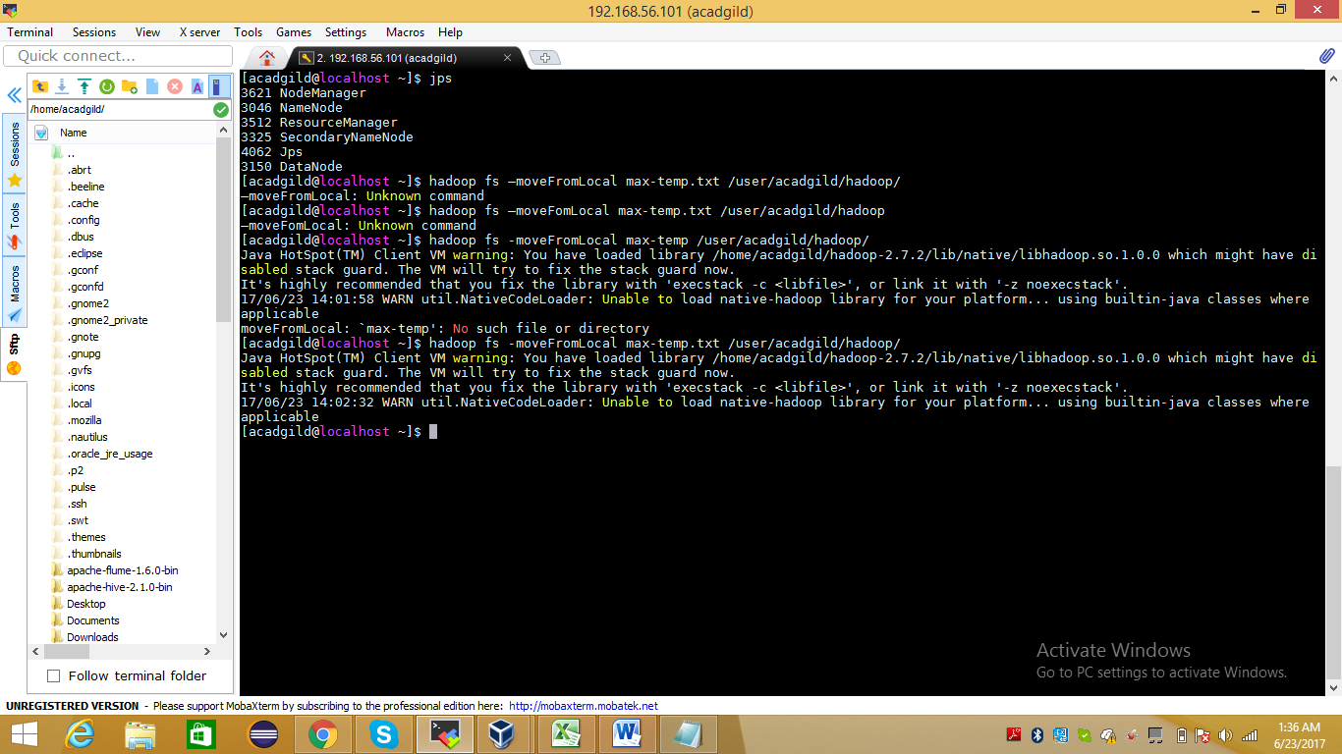

**5) Ran below command and checked file max-temp.txt has successfully moved at /user/acadgild/hadoop/**

**Command : hadoop fs -ls /user/acadgild/hadoop/**

